Ryan Harty

Decision Analysis

Professor Dyer

10/30/19

North Star Assignment

**Introduction**

Lucina Ramirez has hired our consulting team to help her analyze the profitability of a venture that she is passionate about. Ramirez operates a side business where she designs and sells special-event T-shirts. Her regular vendors buy T-shirts for $144 in packs of twelve ($12 per-shirt) and they then proceed to sell shirts at events for $16 apiece. Any shirts that she does not sell to vendors are sold for $2.75 a piece to a local discount clothing store. Ramirez’s supplier sells to her in fixed 2000-unit increments from 4,000 – 8,000 shirts. Ramirez needs our help to determine how many shirts she needs to buy for an upcoming concert featuring the rock band North Star.

**Details**

The stadium that the concert is being held at sits roughly 100,000 people. Ramirez projects that the stadium will likely be half-full for the concert but could vary from 25%-90% of its full capacity. Out of those attending, Ramirez projects 10% of concert goers will buy one of her shirts, but this number could range from 5%-18% of concert goers. Another important consideration is the fact that North Star has cancelled about 10% of their previous shows. If North Start does not perform at the concert, Ramirez will not be able to sell any of her shirts.

**Analysis**

Our analysis will focus on the average projected profitability under uncertainty that Ramirez can expect if she choses from the three order-sizes, 4,000, 6,000 or 8,000. When we aggregated the numbers and looked at base case projected profit, we saw that an order size of 8,000 would yield $36,500 in profits, an order size of 6,000 yields $37,250 in profits and an order size of 4,000 yields $30,250 in profits. After establishing an order size of 6,000 shirts as the winner for the base case, we wanted to examine how the uncertainty of the number of concert goers, demand for shirts, and the concert happening. When we ran our Monte Carlo model with 10,000 simulations, we found that that an order size of 8,000 would yield $36,217 in profits on average, an order size of 6,000 yields $32,489 in profits on average and an order size of 4,000 yields $24,490 in profits on average.

**Conclusion**

After diving into the data and accounting for the uncertainties of the venture, we recommend that Ramirez either orders 8,000 or 6,000 units. The 8,000 units would provide her with the largest average profit, but in the off chance that the concert does not occur, she has spent $31,750 that will not be recovered. Because of this, the order size of 6,000 shirts is also a viable option as its average profits are roughly $4,000 less than the 8,000 shirt’s profits, but the costs are $6,250 less than the 8,000-order size. An order size of 6,000 would decrease her losses if the band doesn’t show and marginally decrease profits, on average, if the band does show. For these reasons, we are recommending these two options to Ramirez and will let her risk tolerance be the deciding factor in which option to implement.

Appendix

|  |  |  |  |  |
| --- | --- | --- | --- | --- |
| Attendance | Tri | Demand | Concert Prob | Extra |
|  |  |  |  | - |
| 50000 | 0.1 | 5000 | 1 | 1,000 |
|  |  |  |  | 3,000 |
|  |  |  |  |  |
| Order Size = | 8,000 | 6,000 | 4,000 |  |
| sales | 5,000 | 5,000 | 4000 |  |
| t-shirt $ | $12 | $12 | $12 |  |
| extra $ | $2.75 | $2.75 | $2.75 |  |
| rev | $68,250 | $62,750 | $48,000 |  |
| cost | $31,750 | $25,500 | $17,750 |  |
| profit | $36,500 | $37,250 | $30,250 |  |
| Mean | $36,200 | $32,474 | $24,529 |  |

Simulation results for order size of 8,000

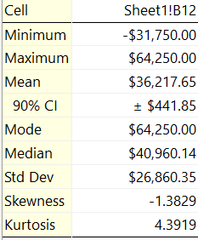

Simulation results for order size of 6,000

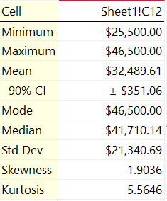

Simulation results for order size of 4,000

